Learning c++

Classes and objects:

Classes is a collection of objects of similar types. The entire set of data and code can be made user defined data types with the help of class. We can have n no. of objects for the same data types. Classes are user defined data types and can use like the built-in types of programming language.

Objects is a basic runtime entity of an object oriented programing. It may represent a person, a place, or any data items that program has to handle. Each object contain data and code to manipulate data.

Data Members and Methods

Class Circle

{

Private:

Double radius:

Public:

void setradius(double);

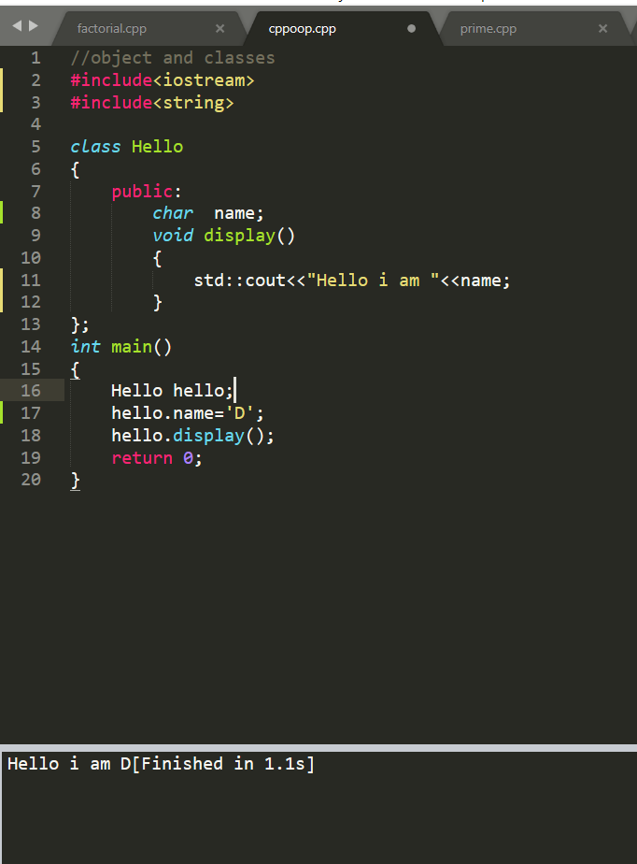 double getdiameter();

